# Project Ironwars – Game Design Document (v3.3 • Phaser 3 Edition)

## 1. World Setting – The Iron Realms

Project Ironwars takes place in the Iron Realms, a continent forged by endless war and powered by arcane industry. Steam, sorcery, spirit power, and forbidden science collide as nations, clans, and cults battle for control of ancient Arcanum Cores—relics of a lost age that fuel War Engines, flying citadels, elemental titans, and necromantic fortresses.

Long ago, the Machinal Concord tried to unify the world under a single banner of order and progress. It shattered in betrayal, and from its ruins emerged new powers: fire-worshipping dwarven empires, skyborn mage academies, spirit-bound clans, undead frost kingdoms, and greedy industrial cartels that sell weapons to every side. The player steps into this fractured world as a Warlord, commanding a mobile Battle Fortress and a band of Commanders, fighting run after run to carve out a legend amid chaos.

## 2. Core Concept

Project Ironwars is a real-time tactical roguelike deck-builder with wave-based battles. Players build a 40-card deck around multiple Commanders, customize a mobile Battle Fortress (War Engine), and progress through a node-based campaign map of 3 stages (15 nodes each, 45 nodes total). Before each enemy wave, the player uses cards to deploy units, structures, and fortress modules onto an isometric grid representing their fortress layout. During real-time combat, cards are disabled—the player instead relies on Commander Skills, fortress abilities, and unit AI to survive.

Runs last roughly 20–60 minutes depending on player choices and difficulty. Bad decisions, poor synergy, or greedy risk-taking can end a run quickly, while mastery over deckbuilding, faction synergies, and fortress design unlocks deeper progression, new Commanders, and powerful relics.

## 3. Core Pillars

• Preparation & Execution – Strategic pre-battle deployment meets high-pressure real-time combat.

• Living Fortress – The Battle Fortress layout, shape, and upgrades drastically impact tactics.

• Wave Warfare – Multi-wave encounters with escalating threats, elite/boss modifiers, and unique mechanics.

• Roguelike Progression – Each run unlocks new Commanders, relics, fortresses, and factions.

• Faction Fantasy – Strong thematic identities across nine factions with unique resources and playstyles.

• Cinematic Industrial Fantasy – Warmachine-inspired 2.5D pixel isometric visuals with steampunk, arcane, and mystical influences.

## 4. Factions of the Iron Realms

The Iron Realms feature nine major power blocs. Each faction offers unique Commanders, cards, War Engines, and mechanics. Players can eventually mix Commanders from multiple factions, though mechanical synergy tends to be strongest within a single faction theme.

### 4.1 Cog Dominion – Greedy Industrial Alliance

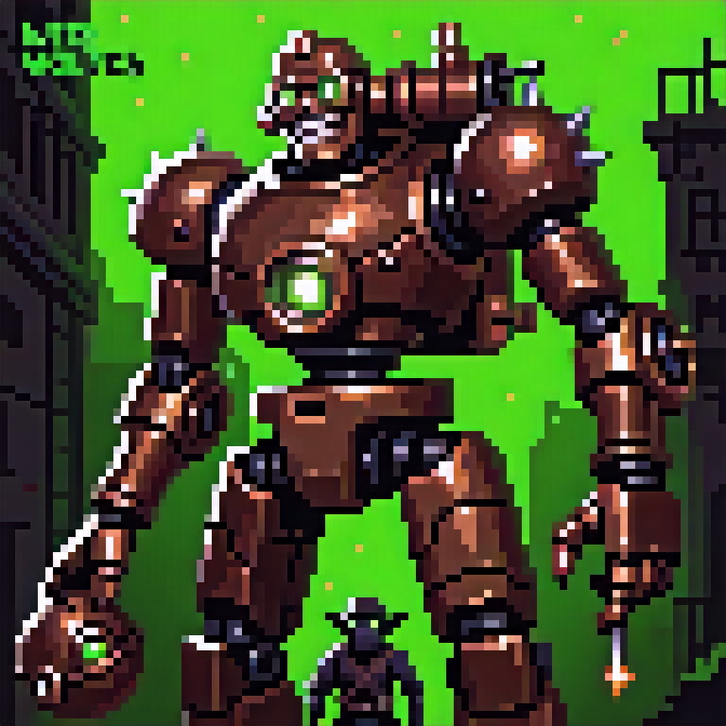

The Cog Dominion is a mercantile-industrial superpower made of greedy Humans, Goblins, and industrial Dwarves. They remain publicly 'neutral' while secretly fueling wars by selling weapons, mechs, and technology to all sides. Ruled by a Triumvirate—Master Blacksmith Dorgun Ironmaw (Dwarf), Master Noble Trader Lucius Goldenthrone (Human), and Master Tinker-Engineer Zibzax Wrenchspark (Goblin)—the Dominion views war purely as profit.

### 4.2 Ember Court of the Molten Forge

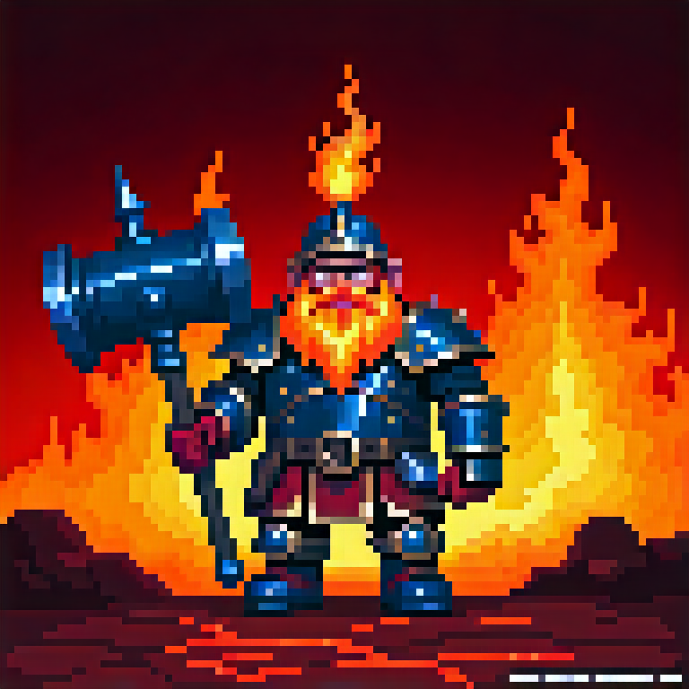

A dwarven fire empire living atop the colossal Flame Titan, a mountain-sized volcanic War Engine. The Ember Court combines pyromantic magic, magma-powered forge tech, and beer-fueled berserker culture. Their fortress appears as a volcano when dormant and strides across battlefields when awakened, shaking the earth and spewing molten death.

### 4.3 Republic of Virel

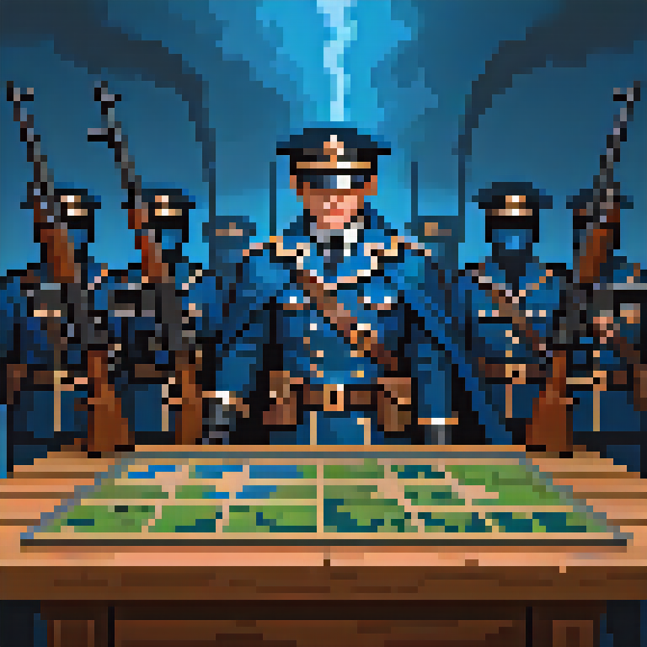

A disciplined human gunpowder nation that blends rifles, artillery, and mana-reactive engineering. They excel at formation tactics, ranged precision, and reliable battlefield control without relying heavily on magic.

### 4.4 Jade Dynasty

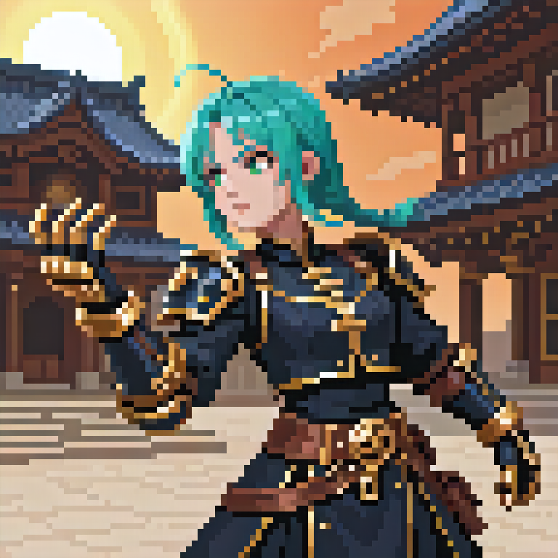

An Eastern Chi-Tech faction of monks, ninjas, and spirit engineers who channel Chi into mechanical exosuits, guardians, and reactors. They emphasize agility, counters, reactive defense, and timing-based skill expression, blending martial arts with brass-and-jade tech.

### 4.5 Sanctum Order of the Radiant Forge

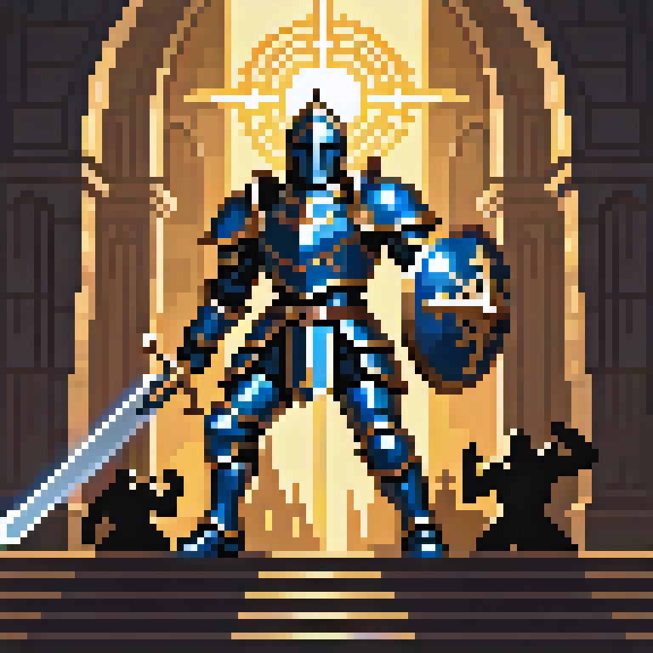

A theocratic order of holy paladins, templars, and radiant engineers who worship a divine machine-spirit. They wield light, shields, and healing, marching from cathedral-fortresses to 'purify' corruption with radiant cannons and sanctified armor.

### 4.6 Verdant Covenant of Mother Gaia



An alliance of High Elves, Druids, Rangers, and Treants bound to the Worldseed. They grow living defenses, control the battlefield with roots and vines, and wield powerful rejuvenation magic. Their armies favor sustain, regrowth, and long-term advantage.

### 4.7 Aetherion Arcana

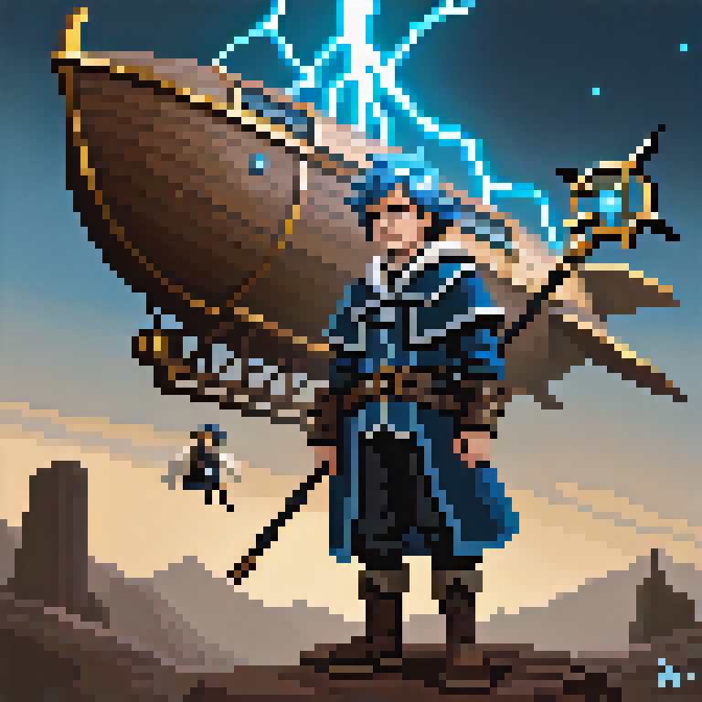

A unified arcane faction combining the former Legion of Aether and the Star Citadel. From the skyborne Aetherion Citadel, storm mages, arcane scholars, and construct engineers harness lightning, astral energy, and aether constructs. They specialize in spell chains, AoE bursts, and flying units fueled by the Aetherstorm resource.

### 4.8 Eternal Frost Clan

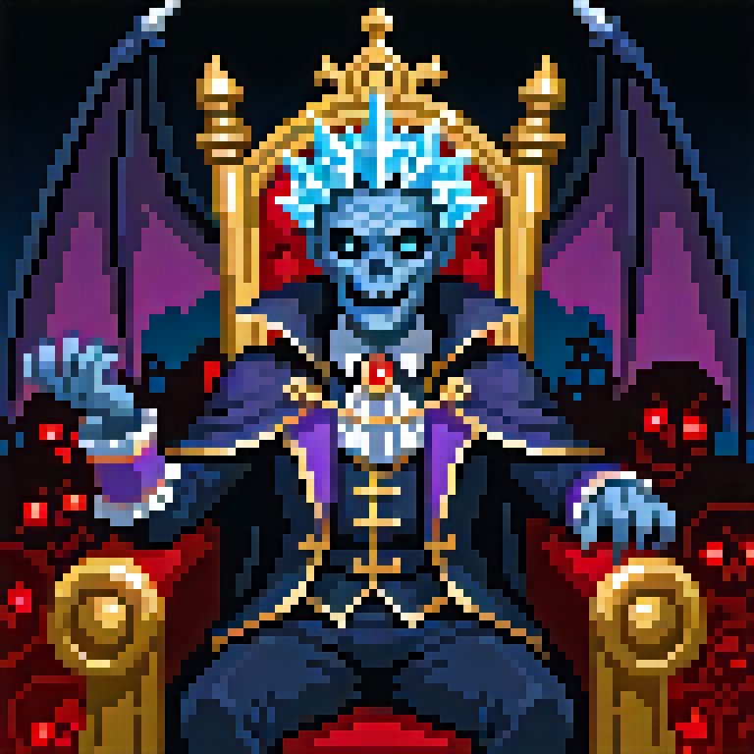

An undead ice dominion ruled by the Vampire-Lich King Azharyl Frostborne, once a human necromancer and mad scientist. They command frozen zombies, frost-infused Frankenstein abominations, soul wraiths, and Nosferatu vampires, all empowered by Soulfrost and cryomancy.

### 4.9 Bloodfang Warborn

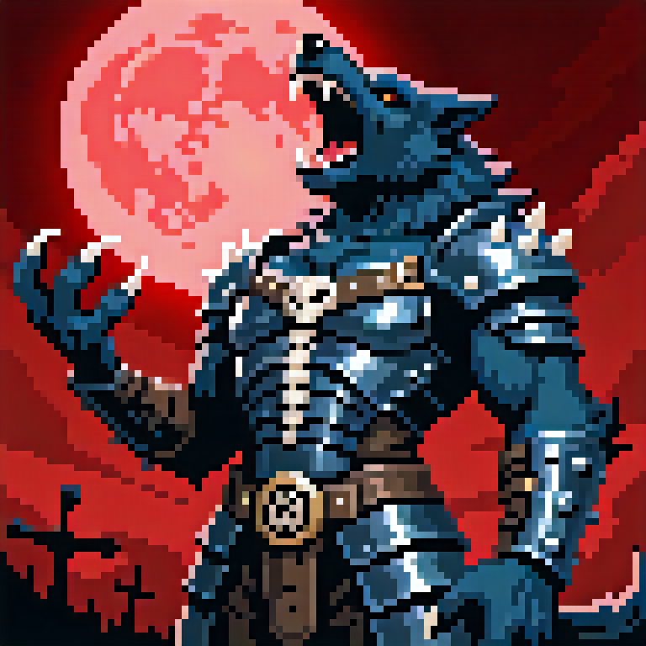

A barbarian werewolf horde cursed to transform into feral beasts in the heat of battle. Spirit Shamans, berserkers, throwing warriors, and howling bards harness Blood Frenzy to trigger transformations, while Alpha Werewolves struggle to keep the pack under control. They reject armor, relying on ferocity and rapid regeneration.

## 5. Player Role & Fantasy

The player is a Warlord, commander of a customizable War Engine and multiple Commanders drawn from various factions. Across each roguelike run, the player makes high-impact strategic decisions: which path to follow, which factions to ally or antagonize, which nodes to risk, and how to evolve their fortress. In battle, they feel like a field commander overseeing a living war machine, controlling the flow of combat indirectly via pre-deployment and Commander Skills.

## 6. Gameplay Flow & Run Structure

Each run consists of a three-stage campaign. Each stage contains 15 nodes (not all combat), for a total of ~45 nodes. Node types include Battle, Elite, Boss, Event, Shop, Recruitment, and Rest. The player starts at Stage 1 and progresses through branching paths toward the Stage Boss, then advances to the next stage until the final showdown.

Combat encounters are wave-based. A normal Battle node has 5 waves of enemies. Elite and Boss nodes have 10 waves, with elite/boss enemies appearing in the final waves. Each wave alternates between a Preparation Phase and a Real-Time Battle Phase.

### 6.1 High-Level Loop

1. Choose Run Setup – Select starting War Engine, starting Commander and deck, difficulty, and any meta-modifiers.

2. Stage Map Navigation – Move between nodes on a branching map; choose battles, events, shops, and rest points.

3. Node Entry – At a Battle/Elite/Boss node, prepare for multi-wave combat.

4. Per-Wave Loop – Preparation Phase → Real-Time Battle Phase → Rewards → Next Wave or Node Resolution.

5. Node Reward & Choices – Gain Gold, Cards, Relics, Fortress Upgrades, Commander unlocks, or healing.

6. Stage Boss – Complete Stage 3 Boss to finish a run; unlock meta progression, new content, and higher difficulties.

### 6.2 Phases of Play (Per Wave)

Phase 1 – Battle Preparation (Pre-Battle Deployment)

• The player uses their deck (up to 40 cards) to deploy units, buildings, support structures, and fortress modules onto an isometric grid layout representing their Battle Fortress. Cards have mana costs and other constraints; the player must decide how to allocate limited resources before combat begins. Once the wave starts, no more cards can be played until the next Preparation Phase.

• The fortress grid shape depends on the selected War Engine. Larger and more advanced fortresses have more cells and unique shapes, supporting different layouts and defensive styles. Upgrading or swapping fortresses is part of long-term progression.

Phase 2 – Real-Time Battle

• Once the wave begins, enemy forces enter from the right/bottom-right side of the landscape isometric battlefield. The player's fortress is positioned on the left/top-left. The camera zooms out to show the entire fortress, allied units, and approaching enemies.

• During this phase, the player cannot play cards. Their focus is on activating Commander Skills, fortress abilities, and reactive powers with cooldowns. Units fight autonomously according to their AI behaviors.

• Multiple Commanders can be part of the deck. Each Commander has a unique active skill. During battle, the player can switch active Commander using number keys (1–5). Only one Commander Skill is 'armed' at a time, but the player can rotate between them strategically. If only three Commanders are present, keys 1–3 are used accordingly.

## 7. Core Systems

### 7.1 Card & Deck System

Cards are the primary tool for shaping the battlefield before combat. Players build a deck of up to 40 cards. Decks can contain multiple Commanders, each contributing their own card pools, plus neutral cards. Too many Commanders can dilute synergy, so deckbuilding decisions matter.

Card Types:

• Unit Cards – Summon troops such as infantry, mechs, rangers, wolves, undead, etc.

• Structure Cards – Place turrets, towers, healing totems, barricades, and production buildings.

• Spell Cards – One-time effects like firestorms, frost blasts, Chi surges, holy shields, or blood rituals.

• Module Cards – Attach modules to fortress cells to boost defense, offense, mana regen, or special mechanics.

### 7.2 Commander System

Commanders represent key heroes/leaders from each faction. Each Commander provides: a passive ability, a set of associated cards, and a unique active Skill usable during Real-Time Battle.

The player can include multiple Commanders in a deck (e.g., up to 3–5). In battle, they switch the active Commander using number keys. Only Commander Skills are usable mid-battle; all card-based deployment remains locked to the Preparation Phases.

### 7.3 Battle Fortress & War Engine System

The Battle Fortress is both a mechanical object and a gameplay board. Its isometric grid shape defines where the player can place units and structures. As the player progresses, they can upgrade their fortress or unlock new ones with larger and more complex shapes.

Examples:

• Iron Syndicate Citadel (Cog Dominion) – A crawling industrial city on treads and gear-legs, focused on production and Profit.

• Flame Titan (Ember Court) – A walking volcanic colossus with magma vents, powerful AoE fire abilities, and awakening mechanics.

• Aetherion Citadel (Aetherion Arcana) – A floating sky fortress with gravity anchors, lightning pylons, and flying deployment points.

• Frozen Sepulcher (Eternal Frost Clan) – A necropolis glacier fortress that emits constant frost aura and undead reinforcements.

• Heartwood Bastion (Verdant Covenant) – A living tree-fortress that expands with growth and regrowth mechanics.

• Maw of the Moon (Bloodfang Warborn) – A bone-and-hide war-camp fortress focused on rituals and spirit beast summons.

### 7.4 Node & Wave Design

Nodes define encounters and choices on the stage map. A standard stage includes 15 nodes, mixing combat and utility.

Node Types:

• Battle Node – 5 waves of enemies. Each wave: Preparation Phase → Real-Time Battle Phase.

• Elite Battle – 10 waves with tougher enemies and modifiers; elite enemies appear prominently in late waves.

• Boss Node – 10 waves with unique boss behaviors, special mechanics, and cinematic intros in the final wave.

• Event Node – Narrative or mechanical choices, e.g., rescue, ambush, cursed relics, random faction interactions.

• Shop Node – Spend Gold/Profit on cards, relics, fortress upgrades, and healing.

• Recruitment Node – Gain new Commanders, units, or faction-specific boons.

• Rest Node – Heal fortress/units, remove curses, or re-roll upcoming nodes at a cost.

### 7.5 Economy, Relics & Meta Progression

During runs, players primarily manage Gold (for shops, events, and node choices) and faction-specific resources like Profit, Chi Flow, Faith, Lifeforce, Aetherstorm, Soulfrost, Heat & Pressure, and Blood Frenzy. Some of these are encounter-only resources; others influence deckbuilding and node strategy.

Relics:

• Provide passive bonuses (e.g., increased damage, faster mana regen, extra fortress modules).

• Some relics are faction-aligned, enhancing specific mechanics (Chi, Faith, Aetherstorm, etc.).

• Others are cursed, providing powerful benefits with serious drawbacks.

Meta progression across runs unlocks new Commanders, relics, fortress types, and additional cards for each faction. Players start with a small roster (e.g., one or two Commanders per faction) and gradually expand their strategic options.

## 8. Visual & Audio Direction

Visuals combine 2.5D pixel art with isometric perspective and modern lighting effects. Each faction has a distinct palette and silhouette language: brass and smoke for Cog Dominion; molten reds and blacks for Ember Court; jade and gold for Jade Dynasty; silver and blue for Aetherion Arcana; pale blues and corpse tones for Eternal Frost; emerald greens and organic shapes for Verdant Covenant; bone and hide for Bloodfang, etc.

Audio pairs industrial soundscapes (hissing steam, clanking metal) with orchestral, ethnic, and choral motifs. Each faction has a musical motif reflecting its identity—holy chants for Sanctum Order, tribal drums and howls for Bloodfang, icy choirs for Eternal Frost, and so on. Dynamic layering intensifies music as waves progress and bosses enter the field.

## 9. Technical Design – Phaser 3 Implementation

Engine: Phaser 3 (JavaScript/TypeScript) using WebGL rendering. Ironwars targets modern desktop browsers with WebGL acceleration enabled. Phaser's Scene system, Cameras, and Tilemap APIs are used to implement the isometric battlefields and fortress layouts.

Core Architecture:

• Language: TypeScript for type safety and maintainability, compiled to JavaScript.

• Scenes: Separate Phaser Scenes for Main Menu, Meta Hub, Run Map (Stage Navigation), Battle, and UI Overlay.

• Rendering: Isometric effect implemented via staggered tilemaps or isometric projection math layered on top of Phaser's orthographic camera. Battlefield is a large tilemap with the player's fortress anchored on the left/top-left and enemies entering from the right/bottom-right.

• Cameras: A primary Camera follows the fortress area and can zoom out enough to show the full fortress and current wave. Optional minor panning to follow key events (boss entrances, Titan awakenings).

• Data-Driven Content: Cards, units, wave definitions, relics, and fortresses are defined in JSON/TS config objects loaded in a preload Scene.

• Physics & Collisions: Phaser's Arcade Physics for lightweight collision detection and overlap checks; custom logic for pathfinding and unit AI.

• Pathfinding: A* or flow-field pathfinding implemented in pure TS on a logical grid layered over the isometric map.

• Effects: Particle emitters for fire, frost, Chi, lightning, holy light, nature motes, blood effects, etc.

Core Systems as Phaser Modules/Managers:

• CardSystem – Manages deck, draw, and available deployment options during Preparation Phase.

• CommanderSystem – Handles Commanders, their passives, and active Skills, including switching via number keys.

• FortressSystem – Manages fortress grid, modules, and War Engine upgrades, integrated with Phaser Tilemaps and GameObjects.

• UnitSystem – Spawns and tracks units, hooks into AI and pathfinding logic.

• WaveManager – Controls wave spawning, pacing, and victory conditions for Battle Scenes.

• ResourceManager – Tracks Gold and faction resources (Profit, Chi Flow, Faith, etc.).

• RelicManager – Applies passive modifiers to other systems.

• MetaProgressionManager – Saves/unlocks content across runs using local storage or a backend API (if present).

Performance Considerations: Use object pooling for units, projectiles, and common effects; minimize texture swaps by batching sprites; use Texture Atlases for faction units; and keep AI/pathfinding computations throttled or spread across frames.

## 10. Controls & Input

PC / Web (Mouse + Keyboard):

• Mouse – Select cards, target fortress cells, and interact with UI.

• Drag and Drop with Left Click – Confirm placement/action.

• Right Click / ESC – Cancel placement or back out of current selection.

• Number Keys (1–5) – Switch active Commander during Real-Time Battle.

• Space (or configurable key) – Trigger the current Commander Skill when off cooldown.

• Q/E/R/F (configurable) – Trigger fortress abilities or wave-related powers.

• WASD / Arrow Keys – Optional camera panning in the Battle Scene if enabled.

## 11. Development Roadmap (High-Level)

• Pre-Alpha – Core Battle Scene in Phaser 3 with card-based Preparation Phase, basic fortress grid, simple AI, and one test faction.

• Alpha – Implement stage map Scene, multi-wave and multi-node structure, 3–4 factions, basic meta progression, and relics.

• Beta – Add all 9 factions, multiple War Engines, full 3-stage campaign, boss fights, and tuned difficulty curves.

• Launch v1.0 – Polished WebGL roguelike with full content, unlockable Commanders, and robust meta systems.

• Post-Launch – Possible PvP mode, co-op experiments, seasonal events, new factions, and additional fortress archetypes.

## 12. Summary Vision

The Phaser 3 edition of Project Ironwars maintains the Warmachine-inspired, card-driven war fortress fantasy while leveraging a mature, WebGL-focused 2D engine tailored for fast iteration and browser deployment. The game remains a fusion of tactical preparation and chaotic real-time combat, where faction identity, fortress design, and commander synergy define each run. Over time, players explore the full spectrum of industrial greed, elemental fury, holy zeal, natural regrowth, arcane storms, undead frost, and cursed bloodlust that define the Iron Realms.